**DOCUMENTATION OF MAJOR ASSIGNMENT:**

**CREATING NEW GIT REPOSITORY:**

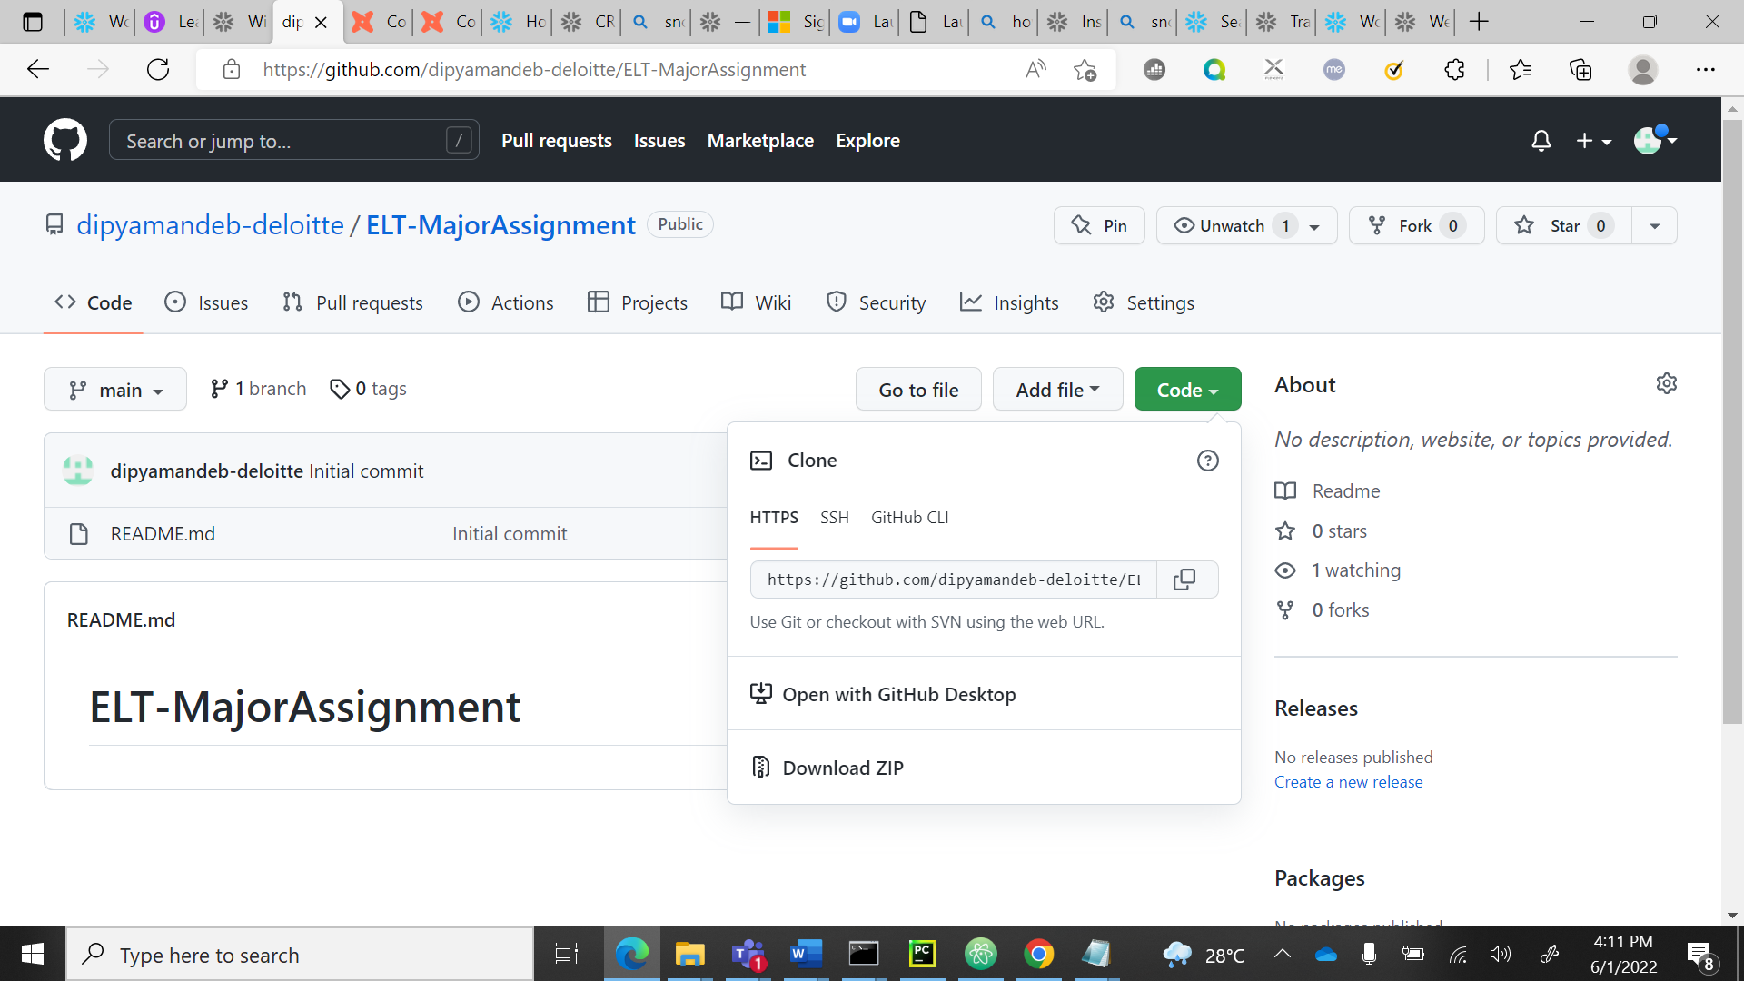

**CLONING DONE:**

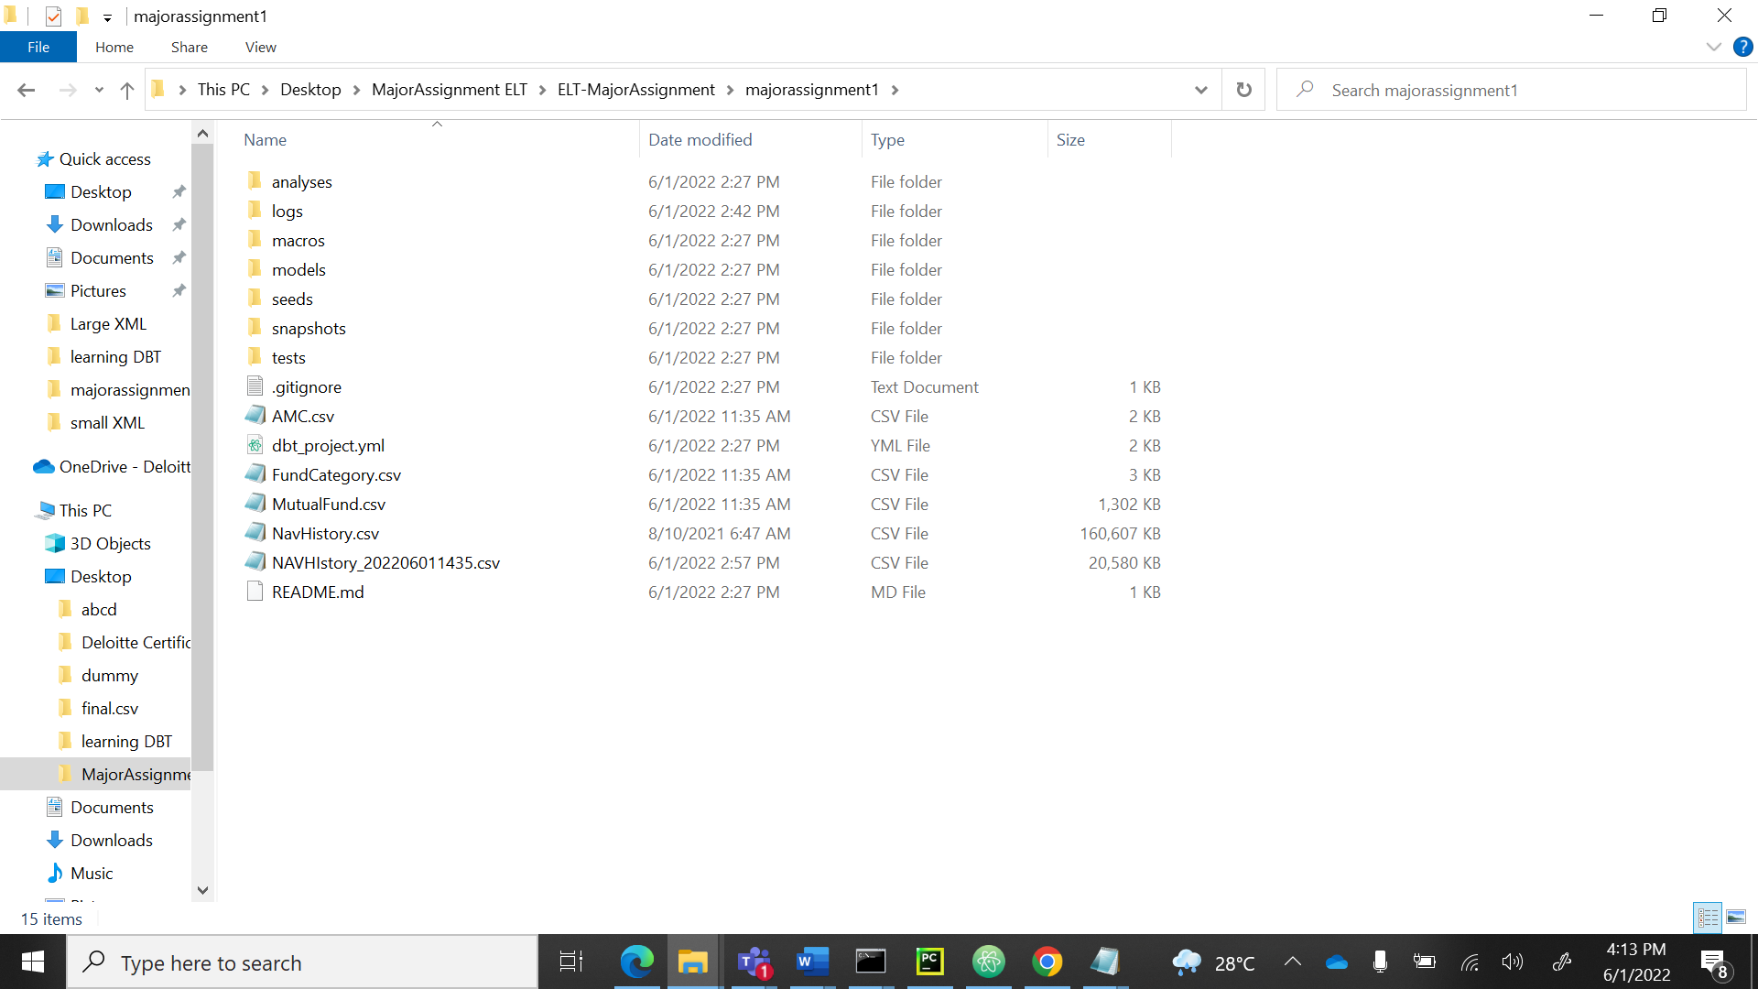

**CREATING NEW DIRECTORY:**

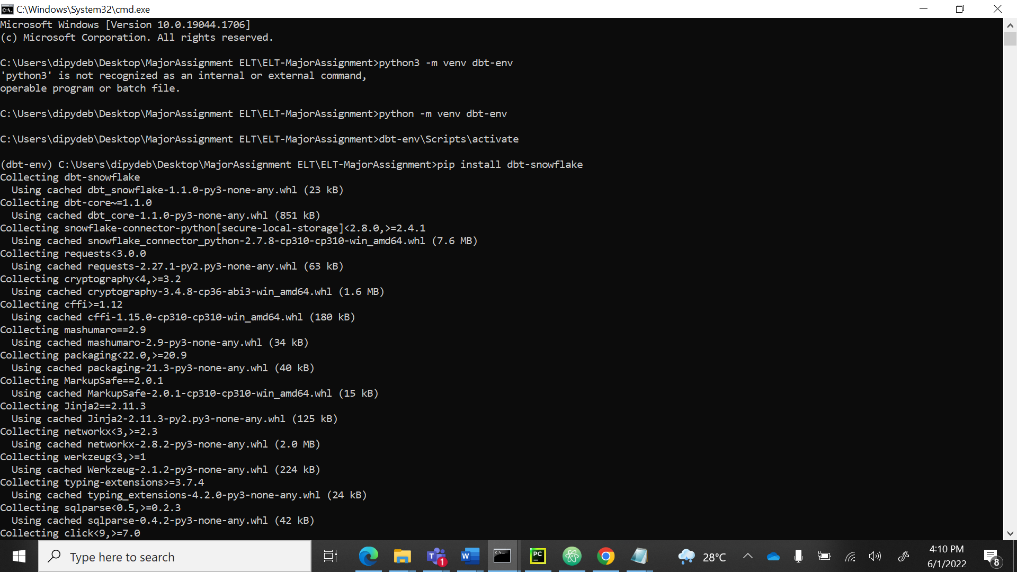

**DBT-DEBUG DONE:**

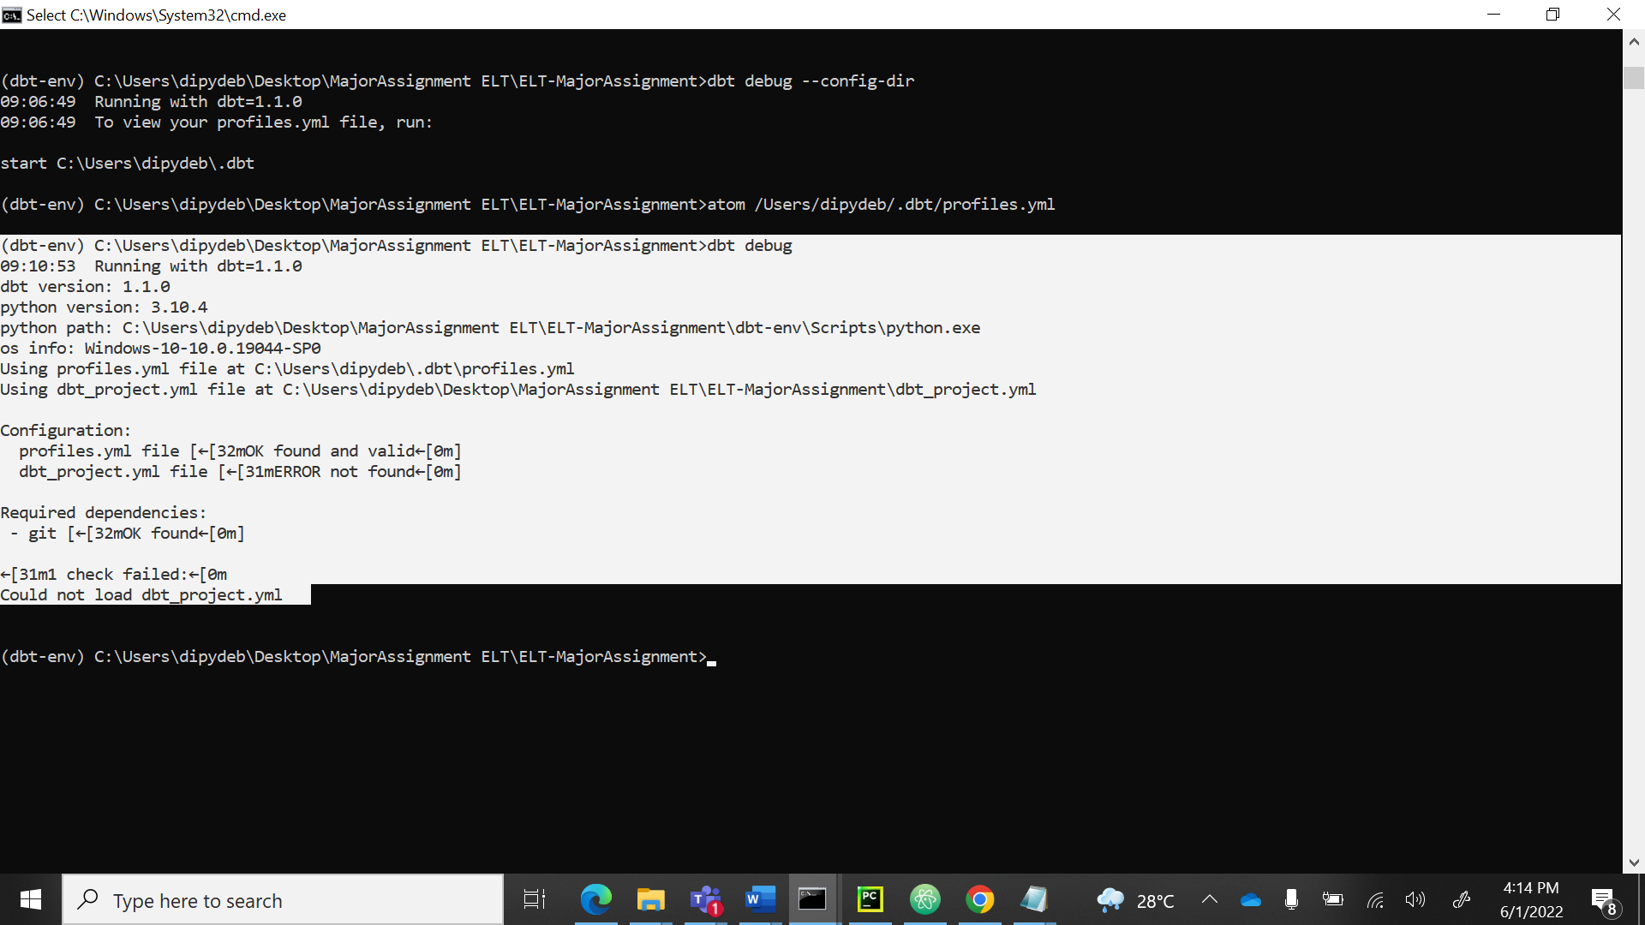

**CSV DATA LOADED:**

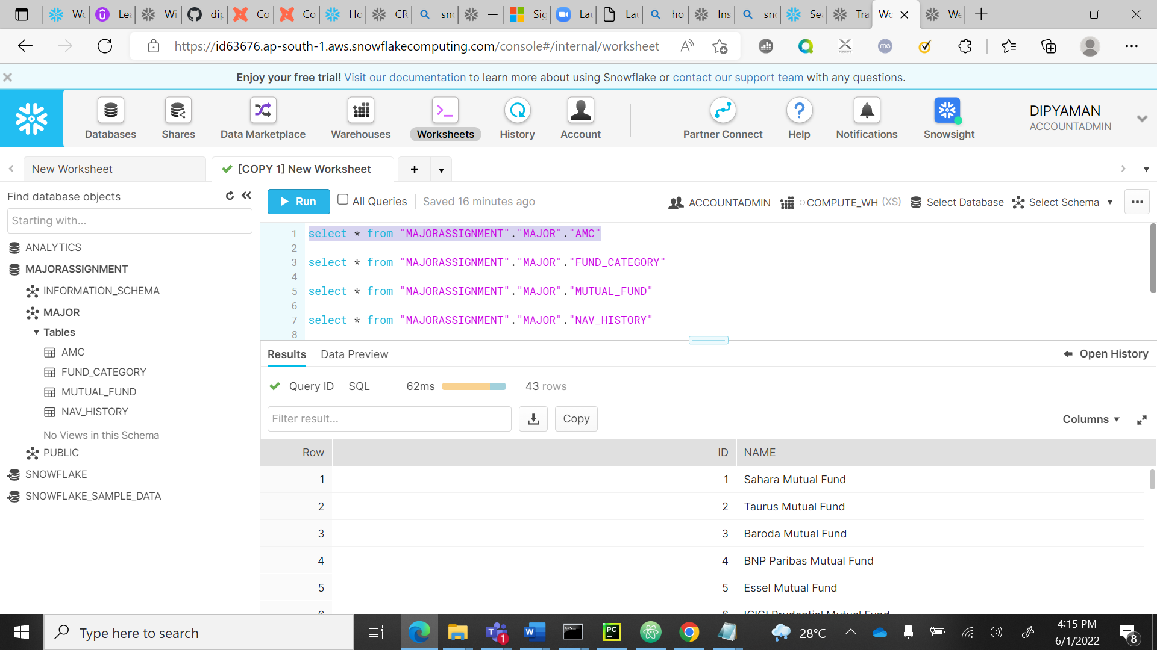

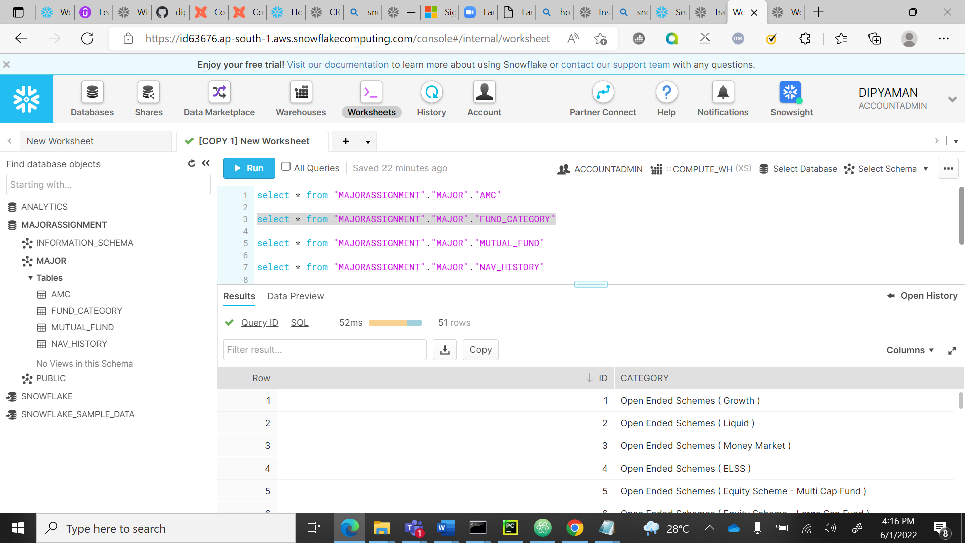

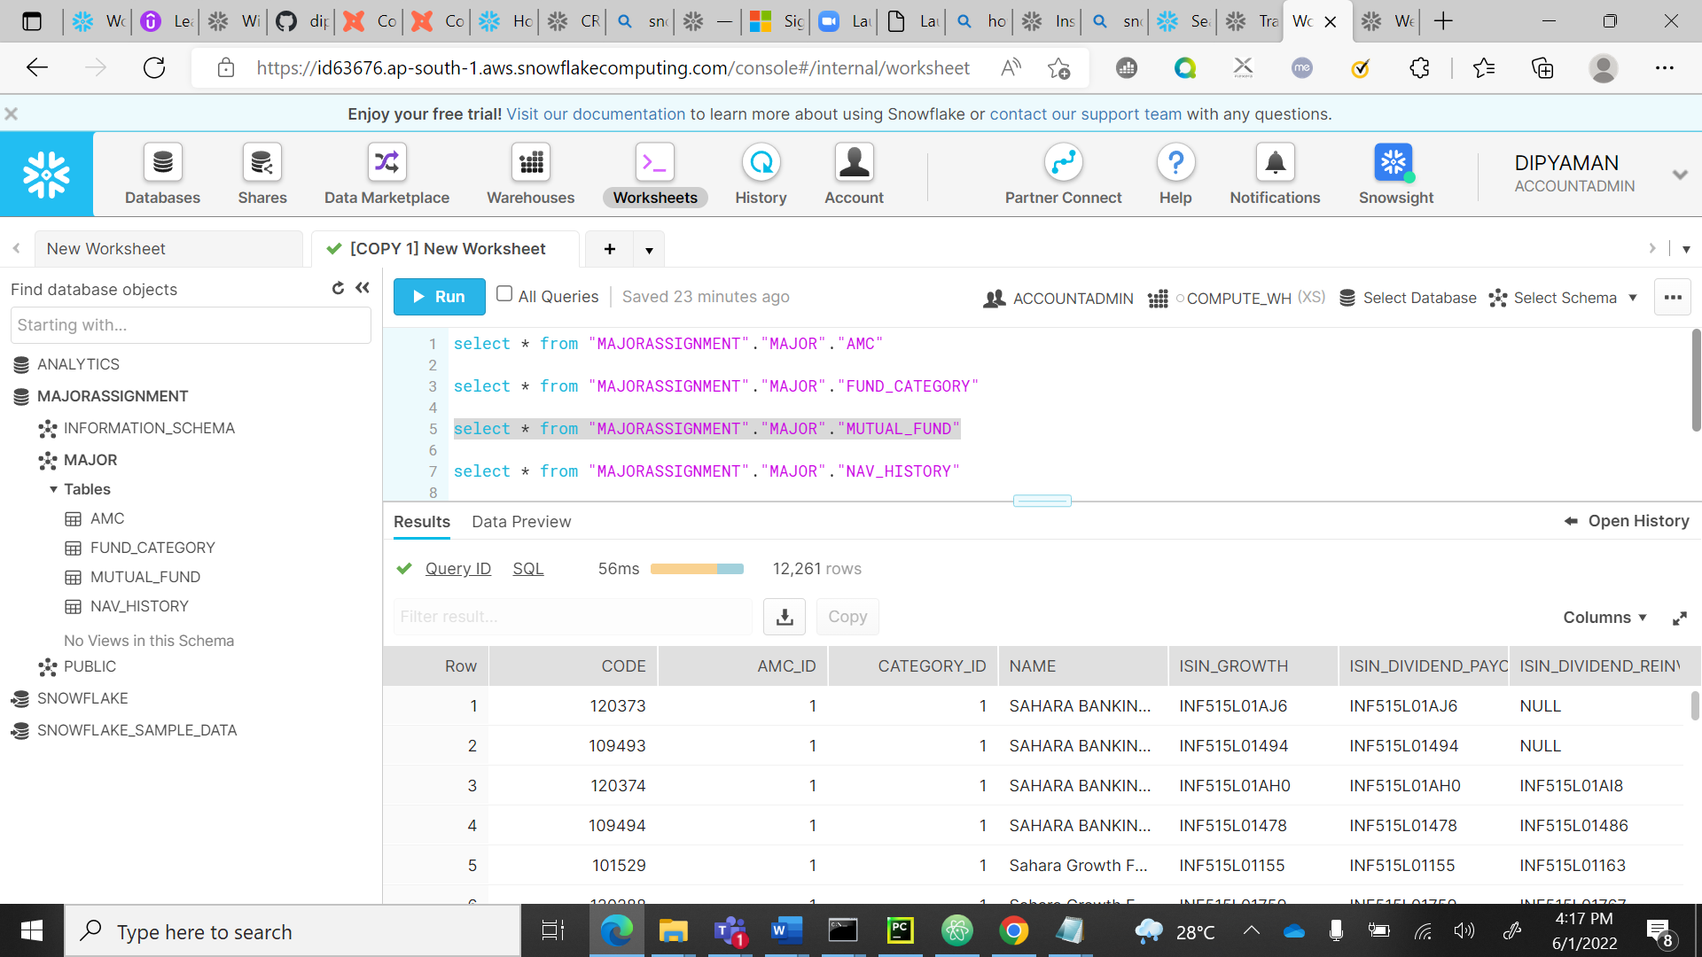

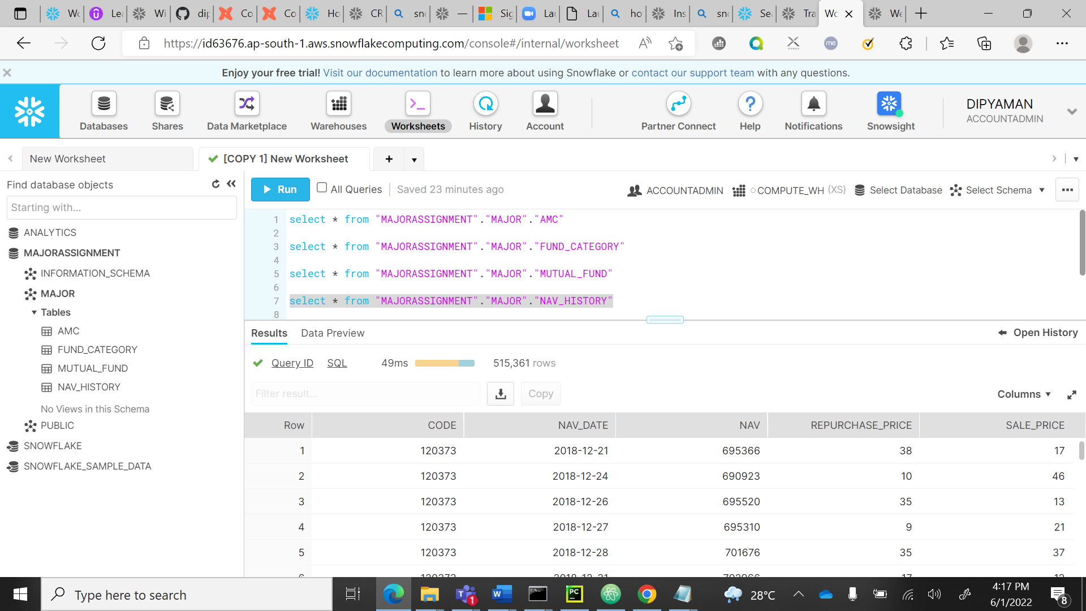

**MILESTONE 1.1:**

**QUERY:**

select code, month(NAV_DATE) as month ,avg(NAV),avg(REPURCHASE_PRICE),avg(SALE_PRICE)

from "MAJORASSIGNMENT"."MAJOR"."NAV_HISTORY"

group by CODE, month;

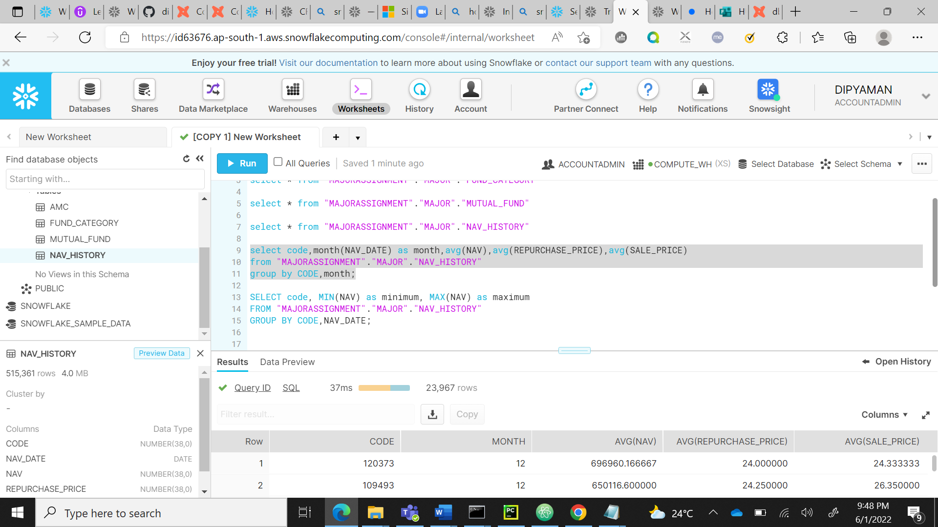

**OUTPUT OF MILESTONE 1.1**

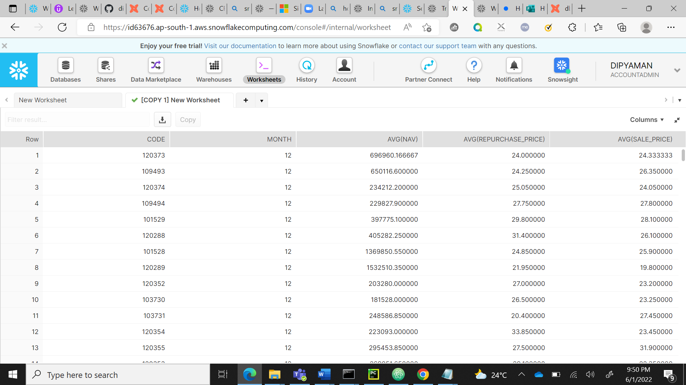

**MILESTONE 1.2**

**QUERY:**

SELECT code, MIN(NAV) as minimum, MAX(NAV) as maximum

FROM "MAJORASSIGNMENT"."MAJOR"."NAV_HISTORY"

GROUP BY CODE;

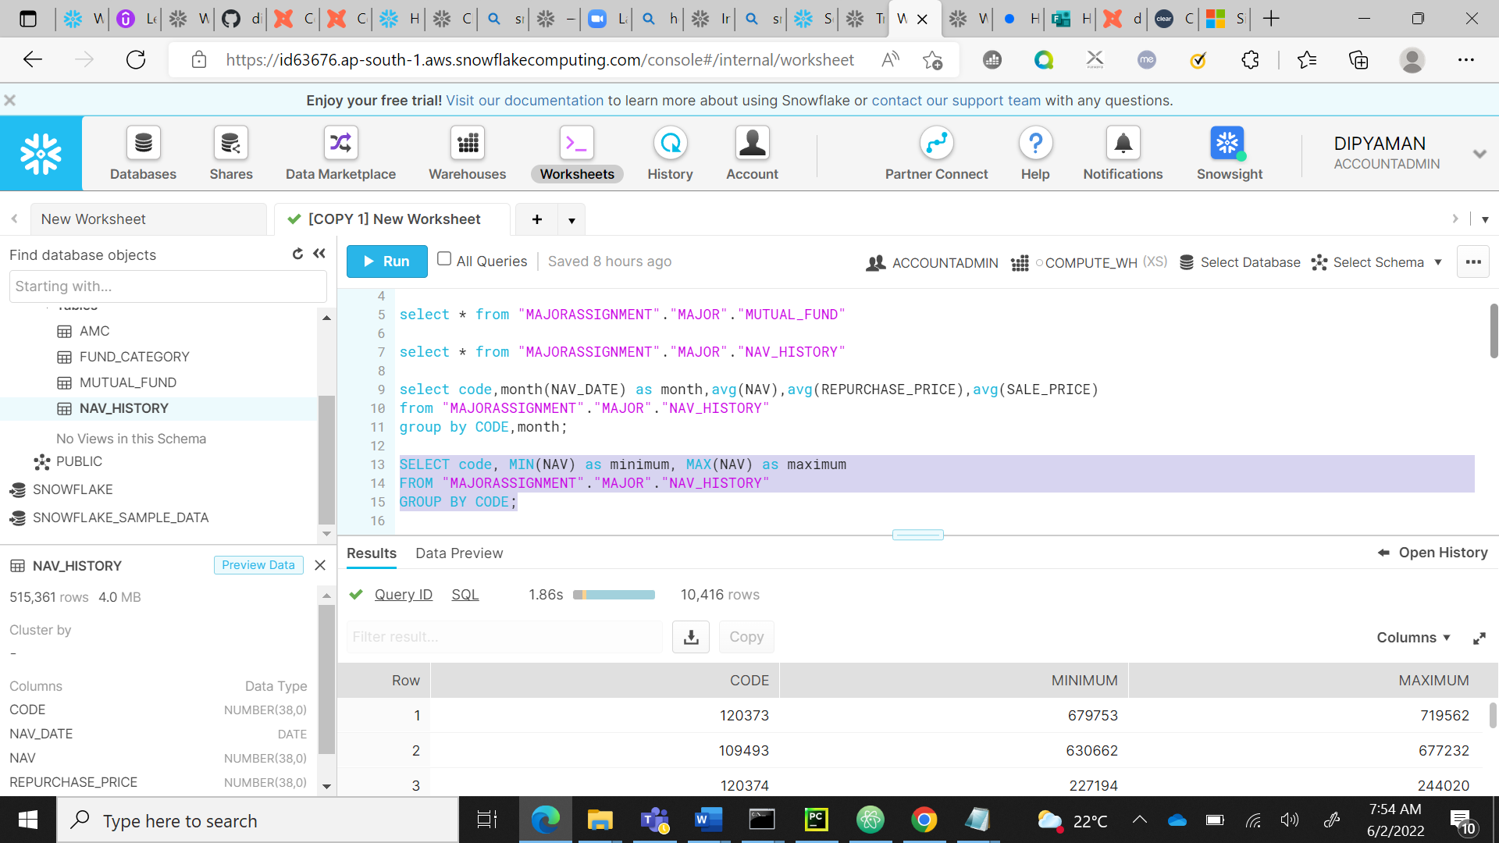

**OUTPUT OF 1.2:**

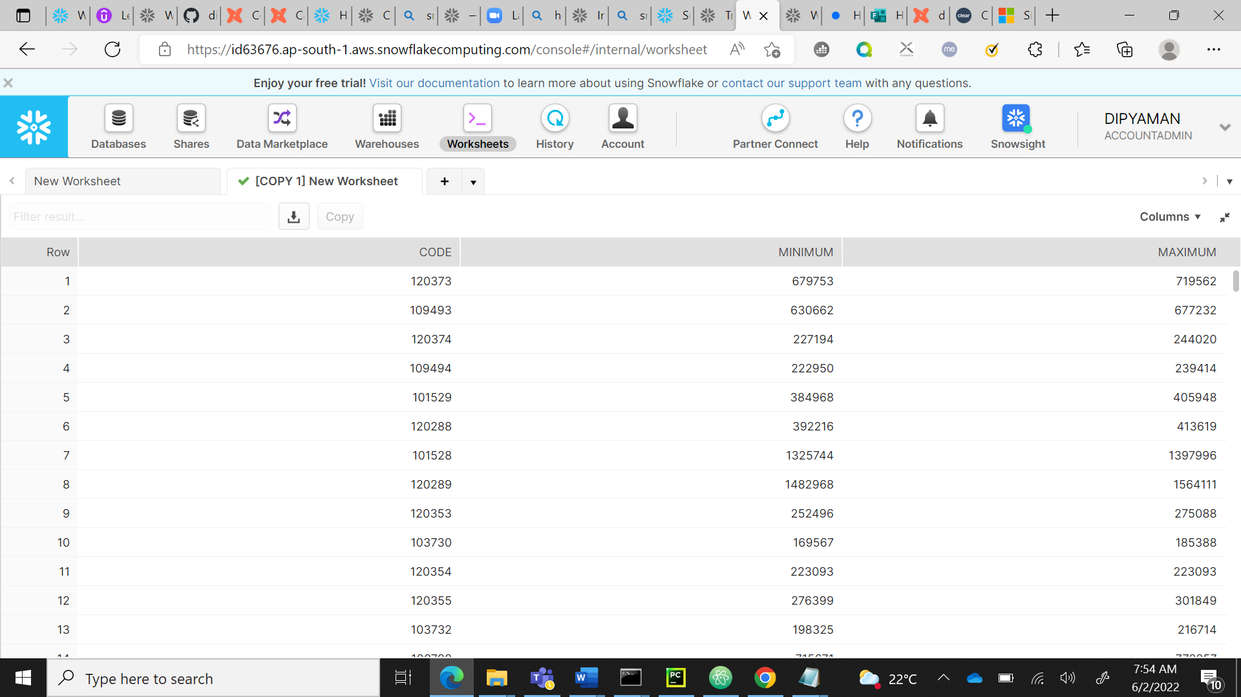

**MILESTONE 2.2:**

**QUERY:**

select c.CODE,c.REPURCHASE_PRICE,c.SALE_PRICE,o.NAME

FROM "MAJORASSIGNMENT"."MAJOR"."NAV_HISTORY" c

LEFT JOIN "MAJORASSIGNMENT"."MAJOR"."MUTUAL_FUND" o

ON c.CODE=o.CODE

GROUP BY c.CODE,c.REPURCHASE_PRICE,c.SALE_PRICE,o.NAME;

**OR**

SELECT distinct r.CATEGORY,r.ID,b.CODE,MONTH(f.NAV_DATE) AS MONTH,f.REPURCHASE_PRICE,f.SALE_PRICE

FROM "MAJORASSIGNMENT"."MAJOR"."FUND_CATEGORY" r

LEFT JOIN "MAJORASSIGNMENT"."MAJOR"."MUTUAL_FUND" b

ON r.ID=b.CATEGORY_ID

INNER JOIN "MAJORASSIGNMENT"."MAJOR"."NAV_HISTORY" f

ON b.CODE=f.CODE;

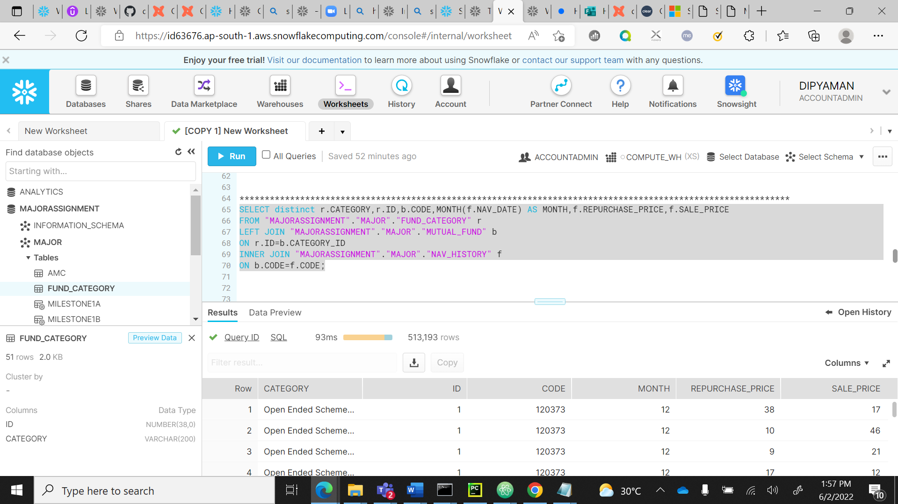

**OUTPUT:**

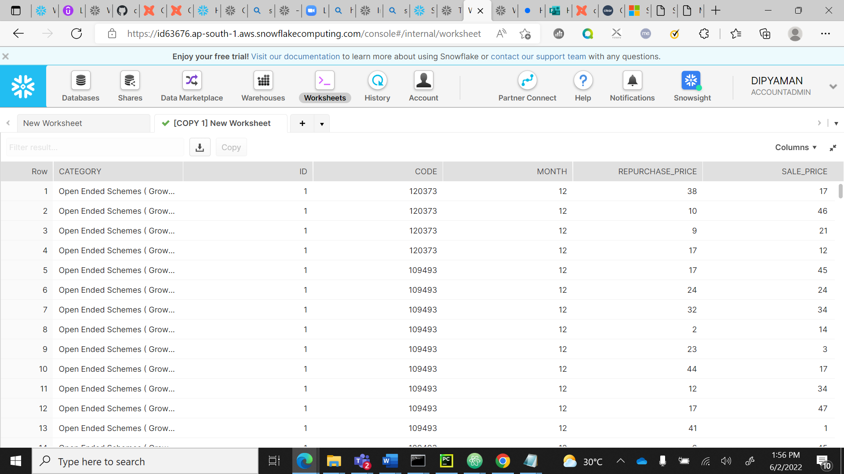

**DATA STUDIO LINKS:**

**Milestone 3A :**[**https://datastudio.google.com/reporting/b1780a08-07e0-483c-8500-80551a01b325**](https://datastudio.google.com/reporting/b1780a08-07e0-483c-8500-80551a01b325)

**Milestone 3D:** [**https://datastudio.google.com/reporting/e10f9835-d134-4a0e-b82f-3c4df9e599e6**](https://datastudio.google.com/reporting/e10f9835-d134-4a0e-b82f-3c4df9e599e6)

**Milestone 3C:** [**https://datastudio.google.com/reporting/b51f82b8-1720-43f4-ba9c-86d9f45fc97c**](https://datastudio.google.com/reporting/b51f82b8-1720-43f4-ba9c-86d9f45fc97c)

**MILESTONE 3A:**

**QUERY:**

**SELECT distinct r.CATEGORY,r.ID,b.CODE,MONTH(f.NAV_DATE) AS MONTH,f.REPURCHASE_PRICE,f.SALE_PRICE**

**FROM "MAJORASSIGNMENT"."MAJOR"."FUND_CATEGORY" r**

**LEFT JOIN "MAJORASSIGNMENT"."MAJOR"."MUTUAL_FUND" b**

**ON r.ID=b.CATEGORY_ID**

**INNER JOIN "MAJORASSIGNMENT"."MAJOR"."NAV_HISTORY" f**

**ON b.CODE=f.CODE;**

**OUTPUT:**

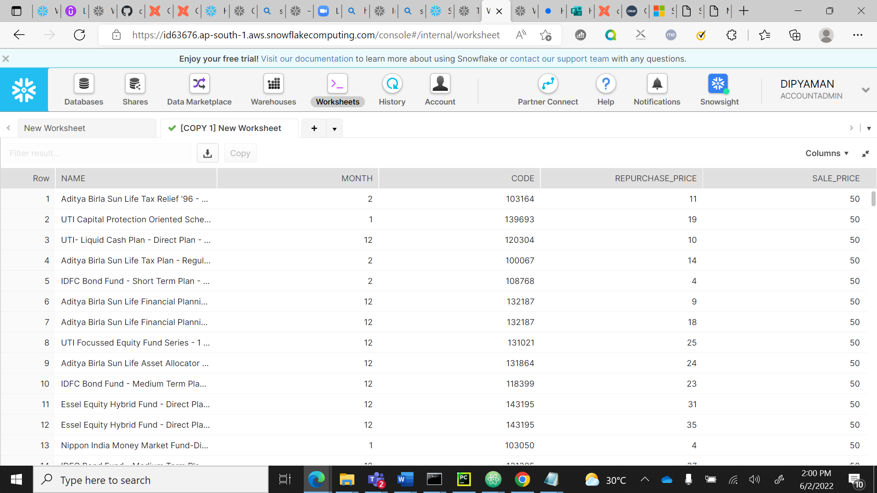

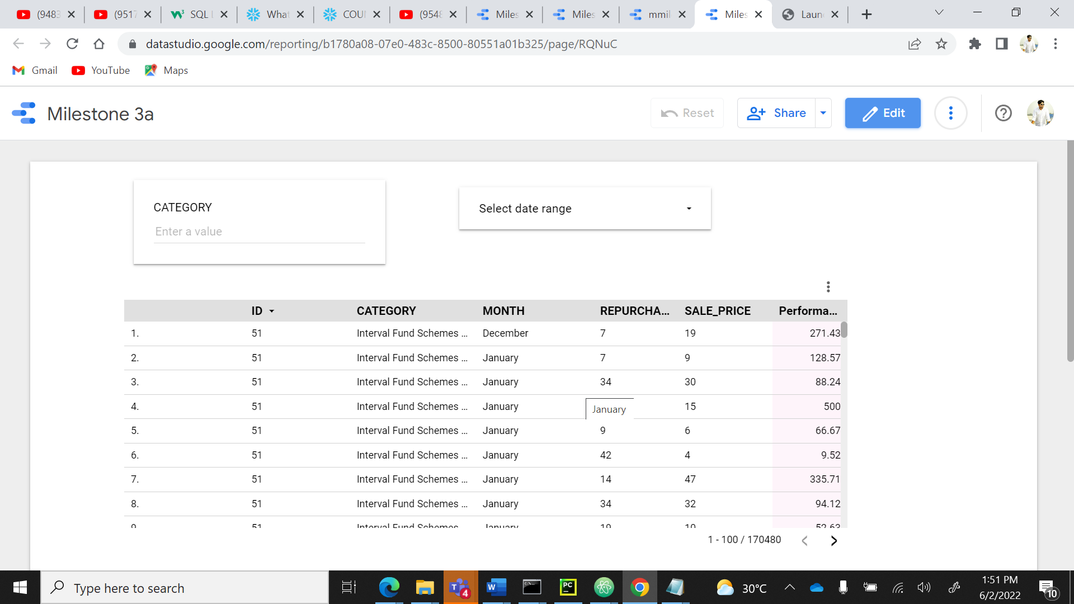

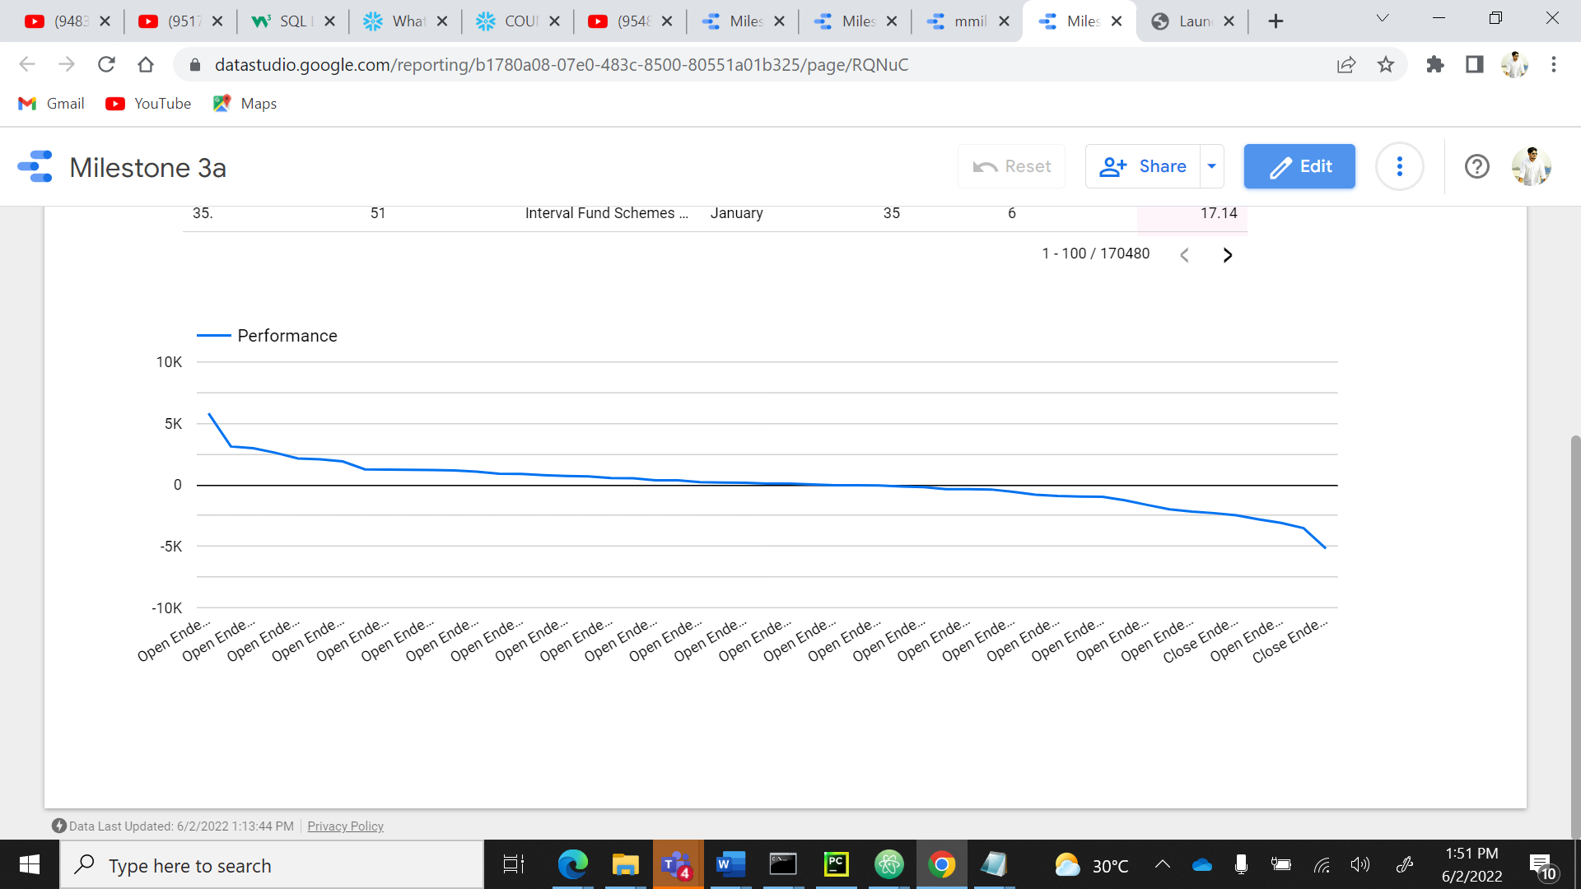

**MILESTONE 3C:**

**QUERY:** **select DISTINCT v.NAME,v.ID,b.CATEGORY**

**FROM"MAJORASSIGNMENT"."MAJOR"."AMC" v**

**left join "MAJORASSIGNMENT"."MAJOR"."FUND_CATEGORY" b**

**on v.ID=b.ID;**

**OUTPUT:**

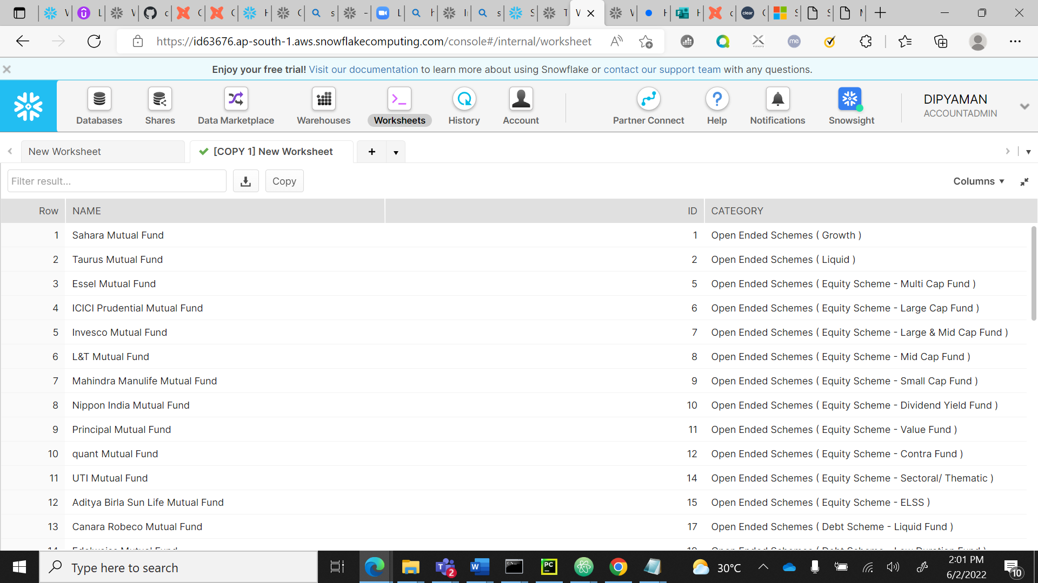

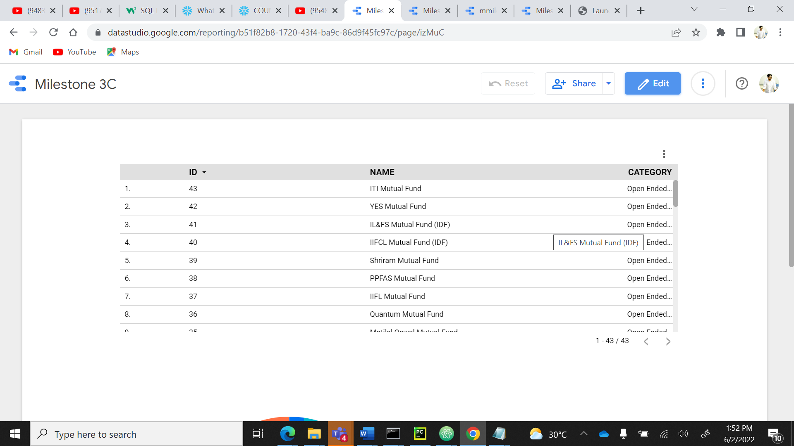

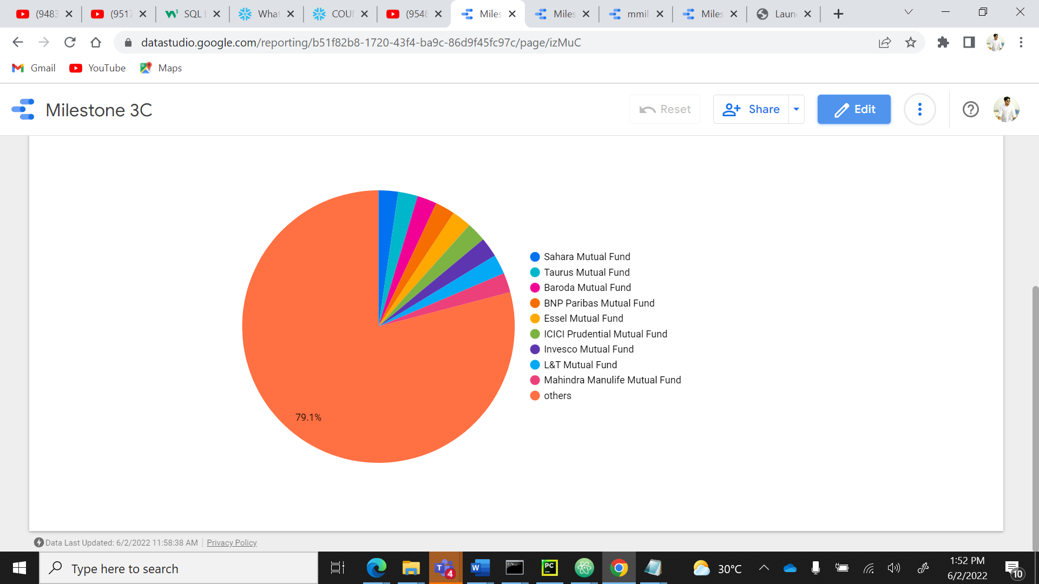

**MILESTONE 3D:**

**QUERY:**

**SELECT distinct r.CATEGORY,r.ID,b.CODE,MONTH(f.NAV_DATE) AS MONTH,f.REPURCHASE_PRICE,f.SALE_PRICE**

**FROM "MAJORASSIGNMENT"."MAJOR"."FUND_CATEGORY" r**

**LEFT JOIN "MAJORASSIGNMENT"."MAJOR"."MUTUAL_FUND" b**

**ON r.ID=b.CATEGORY_ID**

**INNER JOIN "MAJORASSIGNMENT"."MAJOR"."NAV_HISTORY" f**

**ON b.CODE=f.CODE;**

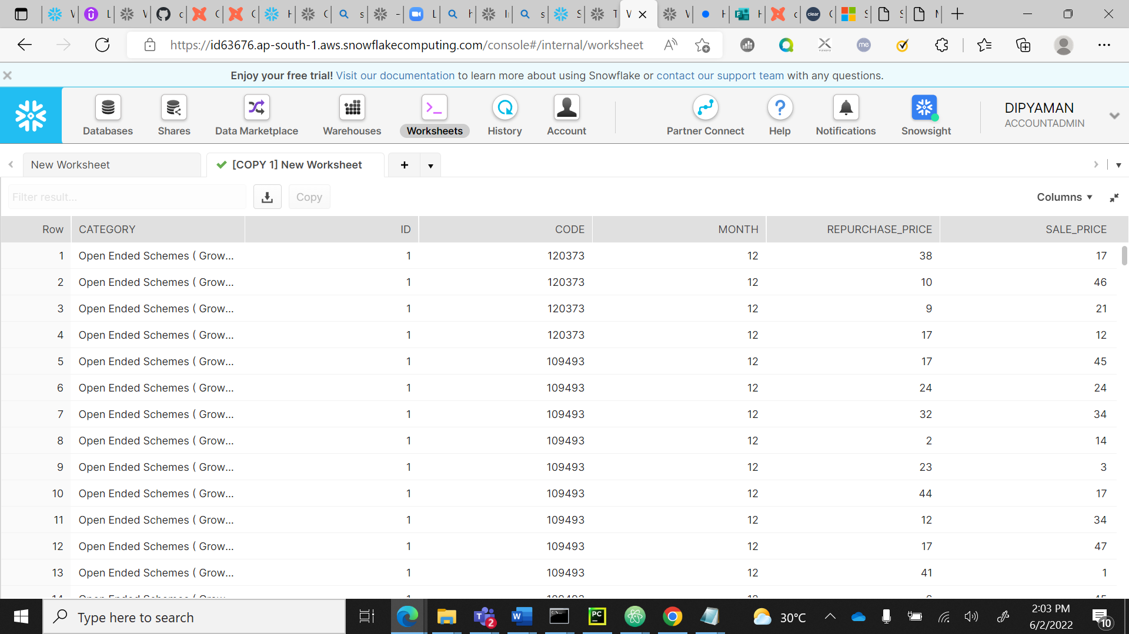

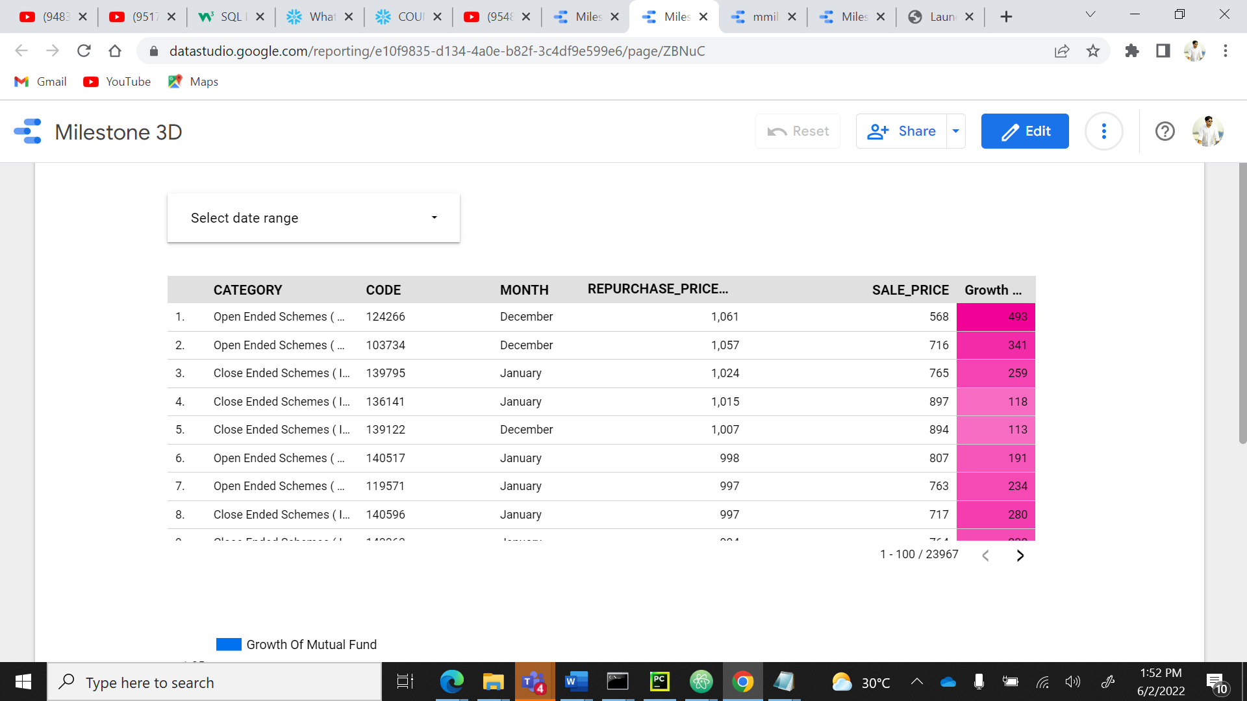

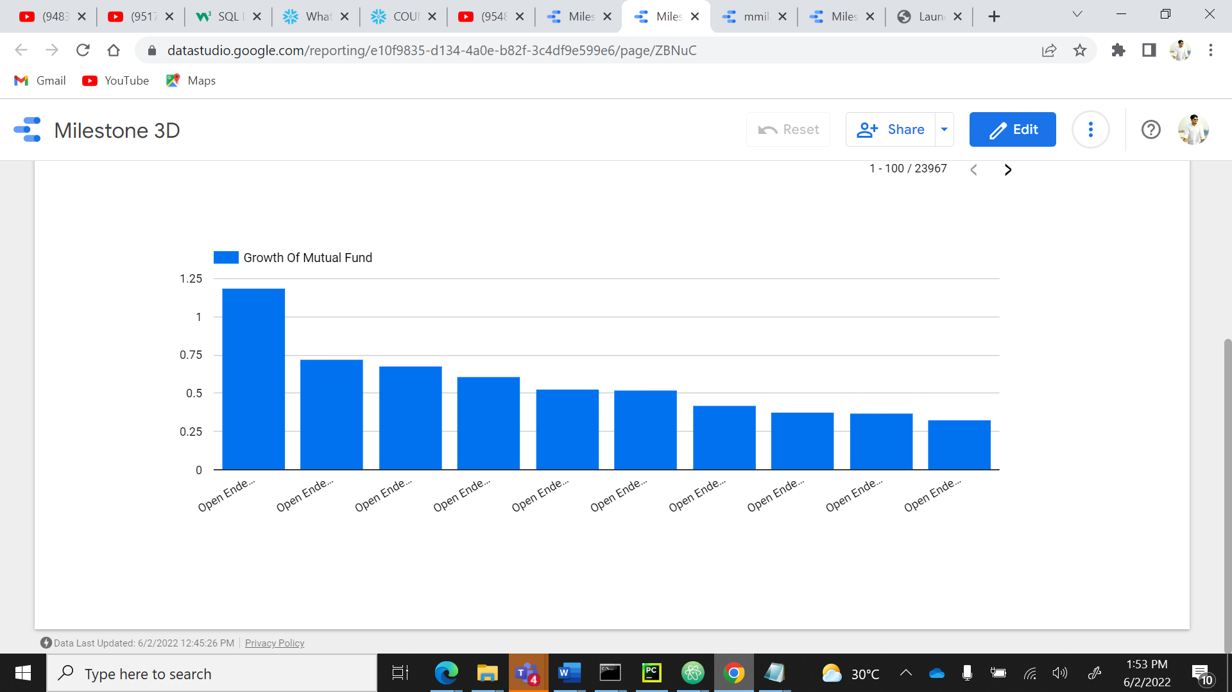

**Milestone 2d:**

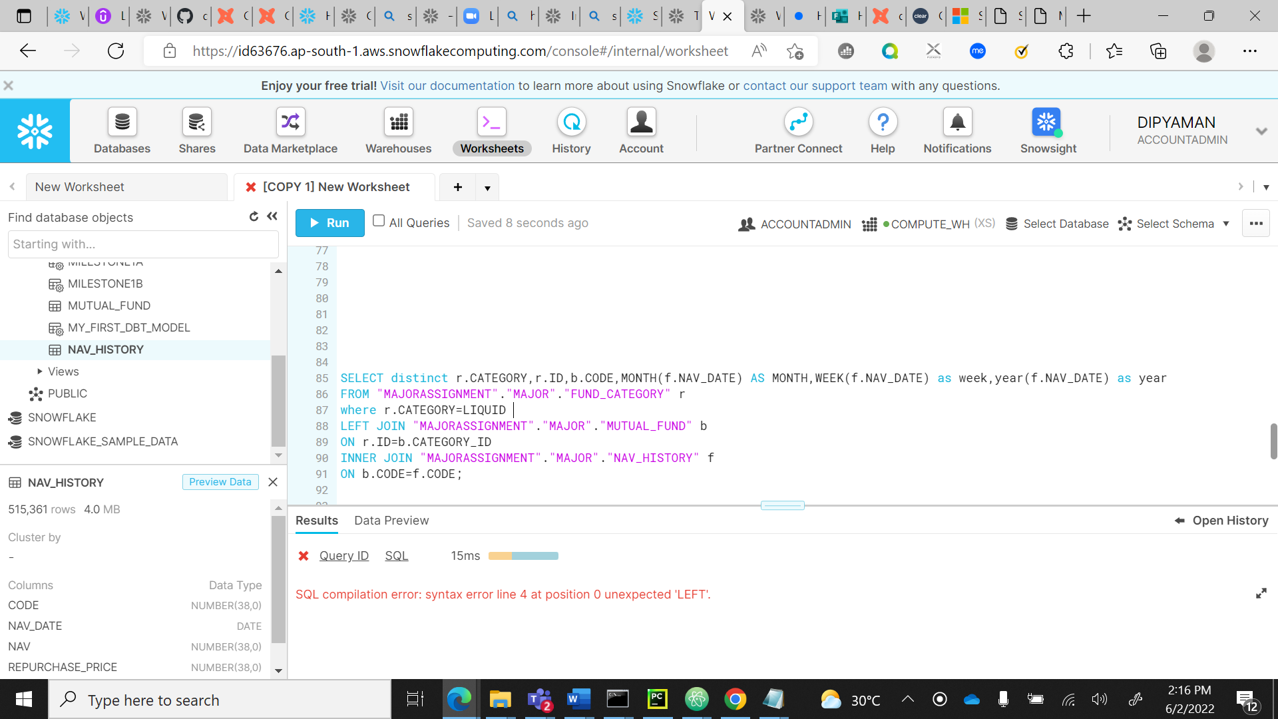

**MY MODELS:**

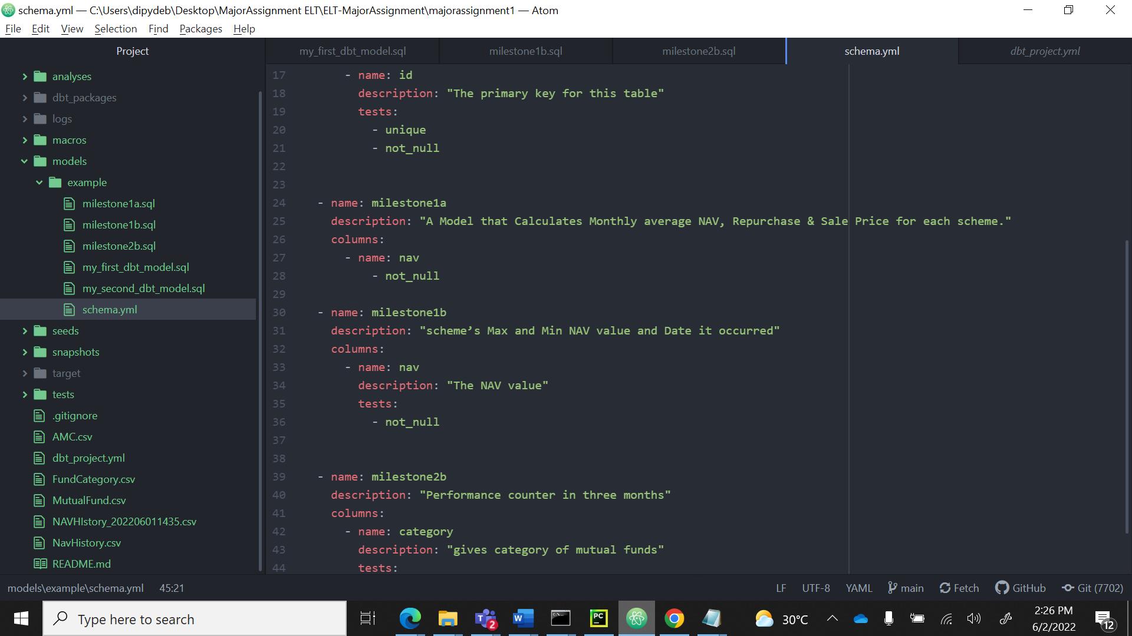

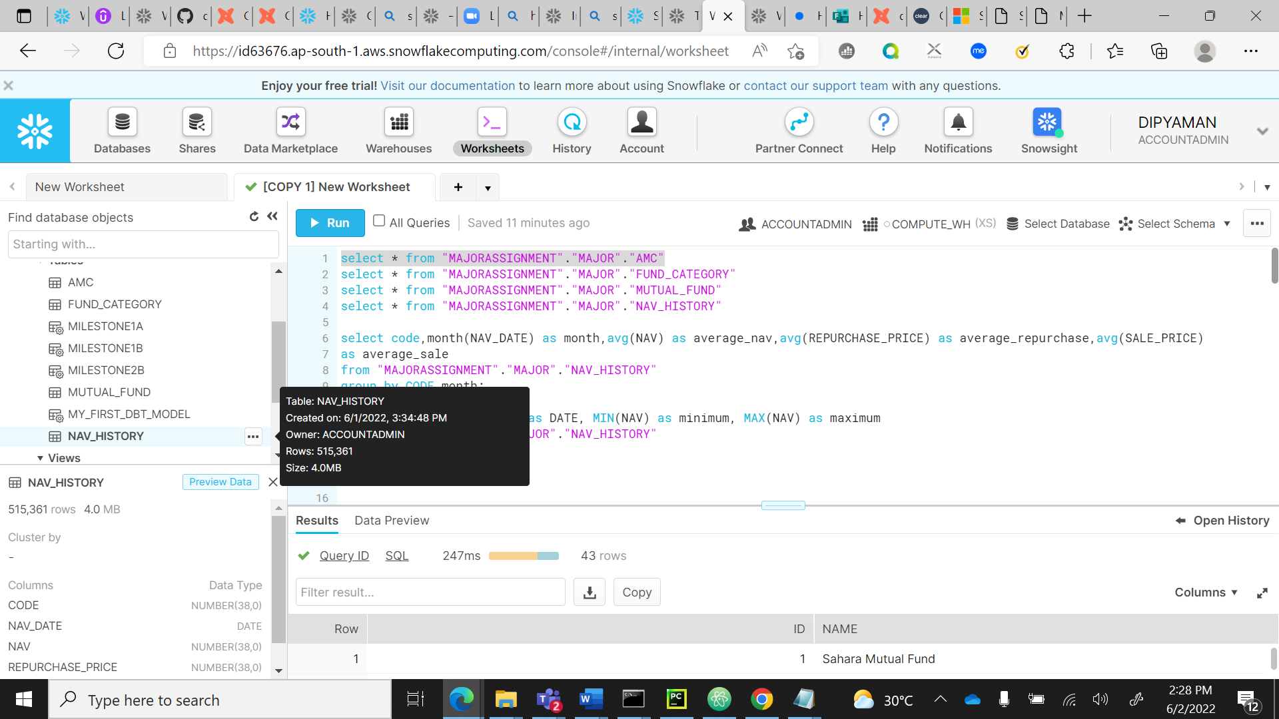

**MY APPROACH TO THE ASSIGNMENT:**

**ERROR:**

* **I tried installing SnowSQL but It was giving Error(AWS Data Load)**
* **I tried to trim the data using Python but It was not working**

**YTD Function was not working:**

**I tried to join for the milestone:2d but It was giving syntax error.**